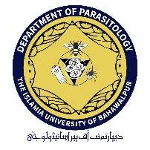
The Islamia University of Bahawalpur
Department of Parasitology

Research Assistant Required

The applications are invited from eligible candidates to fill the following position for a period of one (01) year for the position of Research Assistant under the ORIC-IUB Project entitled “Green synthesis of nanoparticles: a way forward in integrated tick management” under the supervision of Dr. Tauseef ur Rehman (Principal Investigator).

Position Title | Eligibility Criteria | No of  Positions | Employment  Type | Stipend Amount
Research Assistant | Applicant must be enrolled in MPhil Veterinary Sciences, Chemistry or Biochemistry under the supervision of Principal Investigator | 01 | Contract/Project based for 12 months (one year) only. | Rs.10,000  per month

Job Description
The selected candidate will be required to carry out the research responsibilities under the assistance and guidance of Principal Investigator of the project.

Terms & Conditions
- The selected candidate will be required to sign an agreement to work under the supervision of Principal Investigator till the completion of the project.
- The performance of the selected candidate will be evaluated on quarterly basis. If the performance of the selected candidate is not satisfactory, his/her selection will stand cancelled without any prior notice.

How to Apply
- Last date for submission of applications on plain paper along with Statement of Purpose, detailed CV and attested copies of academic testimonials, and experience certificate is 14-07-2023 at the office of Dr. Tauseef ur Rehman (Principal Investigator ORIC IUB Funded Project), Chairman office, Department of Parasitology (Room # EDO 2.26).
- Incomplete and applications submitted after due date will not be entertained. The interview committee reserves the right to reject any/all applications without assigning any reason.
- Only shortlisted candidates will be called for the interviews and no TA/DA will be admissible.

For more details, interested candidates are advised to contact the Principal Investigator during office hours.

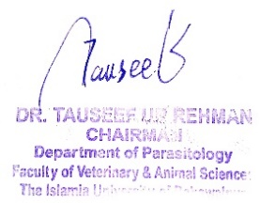
Dr. Tauseef ur Rehman
Associate Professor/ Chairman
Department of Parasitology, FV&AS
Contact: 03345858112
Email: drtauseef@iub.edu.pk

