The Islamia University of Bahawalpur
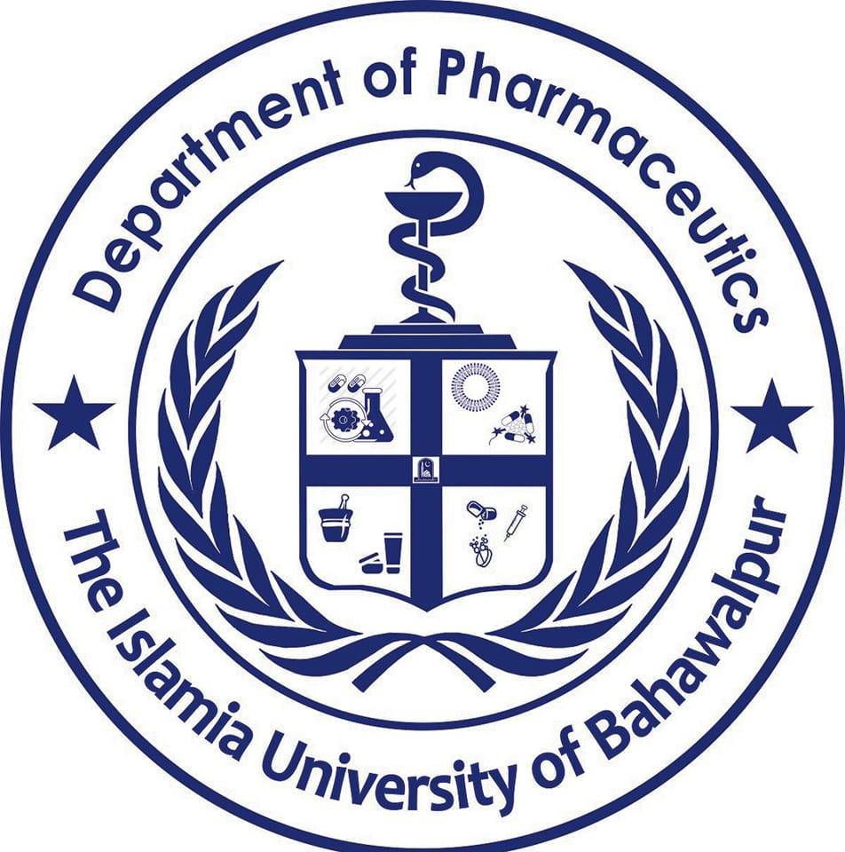
Department of Pharmaceutics

Research Assistant Required

The applications are invited from eligible candidates to fill the following position for a period of one (01) year for the position of Research Assistant under the ORIC-IUB Project entitled “Design and Evaluation of Hybrid Nanoparticles for Transdermal Applications of Lornoxicam” under the supervision of Prof Dr. M. Asadullah Madni (Principal Investigator).

Position Title | Eligibility Criteria | No of  Positions | Employment  Type | Stipend Amount
Research Assistant | Applicant must be enrolled in MPhil Pharmaceutics under the supervision of Principal Investigator | 01 | Contract/Project based for 12 months (one year) only. | Rs.10,000  per month

Job Description
The selected candidate will be required to carry out the research responsibilities under the assistance and guidance of Principal Investigator of the project.

Terms & Conditions
- The selected candidate will be required to sign an agreement to work under the supervision of Principal Investigator till the completion of the project.
- The performance of the selected candidate will be evaluated on quarterly basis. If the performance of the selected candidate is not satisfactory, his/her selection will stand cancelled without any prior notice.

How to Apply
- Last date for submission of applications on plain paper along with Statement of Purpose, detailed CV and attested copies of academic testimonials, and experience certificate is 26-07-2023 at the office of Prof Dr. M. Asadullah Madni (Principal Investigator ORIC IUB Funded Project) Department of Pharmaceutics, Faculty of Pharmacy, The Islamia University of Bahawalpur).
- Incomplete and applications submitted after the due date will not be entertained. The interview committee reserves the right to reject any/all applications without assigning any reason.
- Only shortlisted candidates will be called for the interviews and no TA/DA will be admissible.

For more details, interested candidates are advised to contact the Principal Investigator from 11:00 Am to 01: 00 PM.

Prof. Dr. M. Asadullah Madni
Chairman, Department of Pharmaceutics, Faculty of Pharmacy
The Islamia University of Bahawalpur
Punjab- Pakistan
Contact no: 0092-300-6821979
Email: - Asadullah.madni@iub.edu.pk
asadpharmacist@hotmail.com

